Software Requirements Specification (SRS)

Project: AI Driven Healthcare And Scheduling System (Medicare PLUS)

1. Introduction

1.1 Purpose
This SRS defines the functional and non-functional requirements for the Healthcare Appointment Management System (“CareSync”). It is intended for developers, testers, product owners, and stakeholders to align on scope, interfaces, constraints, and acceptance criteria.

1.2 Scope
CareSync digitizes the patient–doctor lifecycle:
- Patient onboarding, authentication (OTP), and profile management
- Doctor management, schedules, availability, and workload analytics (heatmaps)
- Appointment booking (online/offline), reminders, rescheduling, cancellation
- AI-powered lab report analysis and medical records workflow
- Real-time updates via websockets, comprehensive audit logging

1.3 Definitions and Acronyms
- RBAC: Role-Based Access Control
- OTP: One-Time Password
- MFA: Multi-Factor Authentication
- PII/PHI: Personally/Protected Health Information
- DFD: Data Flow Diagram
- JWT: JSON Web Token

1.4 References
- Root README (run/deployment): `README.md`
- Backend README (OCR/AI setup): `backend/README.md`
- Frontend app (React + Vite): `Software-Grp-Project/`
- Docker orchestration: `docker-compose.yml`

1.5 Overview
Sections 2–8 cover the product perspective, users, features, interfaces, data, quality attributes, and acceptance criteria. Section 9 maps APIs and data models. Section 10–14 list assumptions, constraints, risks, verification strategy, acceptance criteria, deployment/ops, and traceability.

---

2. Overall Description

2.1 Product Perspective
- Frontend: React (Vite) SPA with patient/doctor/admin dashboards
- Backend: Node.js/Express REST API with Socket.io and MongoDB
- AI: Server endpoint(s) integrating Gemini and OCR for lab report parsing
- Deployment: Dockerized services; environment variables for config

2.2 Product Functions (High Level)
1) Identity and access management with OTP/MFA, sessions, and profile
2) Appointment lifecycle management with collision checks and reminders
3) AI report analysis pipeline with file upload and review workflow
4) Analytics: heatmaps and doctor stats; audit logging
5) Real-time updates for booking confirmations and dashboard refresh

2.3 User Classes and Characteristics
- Patient: schedules appointments, uploads reports, views records
- Doctor: manages availability, reviews AI analysis, updates prescriptions
- Admin: oversees users, departments, hospitals, and audits

2.4 Operating Environment
- Server: Node.js 18+, MongoDB 6+, optional Python OCR env
- Client: Modern browsers (Chrome, Edge, Firefox, Safari), responsive UI
- Network: HTTPS/TLS 1.3 in production

2.5 Design and Implementation Constraints
- Stateless API for horizontal scaling
- Secure file handling in `backend/uploads` (consider S3 in production)
- Rate-limiting for auth endpoints
- JWT-based auth; refresh token rotation
- Logging and PII handling in compliance with applicable regulations

2.6 Assumptions and Dependencies
- Email service configured for OTP and notifications
- Stable Gemini API/OCR model availability
- Timezone and locale handling on client and server
- Third-party services (SMTP, AI APIs) maintain acceptable SLAs

---

3. External Interface Requirements

3.1 User Interfaces
- Accessible, responsive dashboards for all roles
- Real-time notifications/toasts; appointment heatmap visualization
- File upload UI for reports/prescriptions; progress indicators
- WCAG 2.1 AA color contrast and keyboard navigation for all critical flows

3.2 Software Interfaces
- MongoDB: users, appointments, records, sessions, audit logs
- Gemini/AI service: medical report analysis
- Socket.io: bidirectional event updates

3.3 Communications Interfaces
- REST over HTTPS (JSON)
- WebSocket (Socket.io) over TLS
- Email (SMTP) for OTP/reset notifications
- Time synchronization via NTP (assumed at OS level)

---

4. System Features and Functional Requirements

4.1 Authentication and Account Security
- REQ-AUTH-1 RBAC must restrict endpoints to `patient`, `doctor`, `admin`.
- REQ-AUTH-2 OTP verification during registration and sensitive actions.
- REQ-AUTH-3 Rate-limit sensitive auth routes.
- REQ-AUTH-4 Account lock after 5 failed logins; `lockUntil` controls unlock.
- REQ-AUTH-5 Refresh token rotation; revoke on logout or anomaly.
- REQ-AUTH-6 Profile view/update for authenticated users.
- REQ-AUTH-7 Device/location change should trigger security notification; optionally require re-auth.

4.2 Appointment Management
- REQ-APPT-1 Create bookings with unique `appointmentId`.
- REQ-APPT-2 Modes: `Online` (video) and `Offline` (in-clinic).
- REQ-APPT-3 Statuses: `upcoming`, `completed`, `cancelled`; rescheduling requires reason.
- REQ-APPT-4 Patient can view “my appointments”.
- REQ-APPT-5 Heatmap endpoint returns 7×24 density matrix.
- REQ-APPT-6 Urgent flag `isUrgent` to prioritize queueing.
- REQ-APPT-7 Send reminders at 24h and 2h (idempotent flags).
- REQ-APPT-8 Collision detection for overlapping doctor slots must prevent double-booking.
- REQ-APPT-9 Cancellation policy windows and reasons must be recorded.

4.3 Medical Records and AI Analysis
- REQ-MR-1 Patients can access their own records; doctors/admins can access authorized patient records.
- REQ-MR-2 Upload lab report files; server stores metadata and path/URL.
- REQ-MR-3 AI analysis extracts structured insights, stored in `analysis`.
- REQ-MR-4 Records lifecycle: `pending` → `reviewed` → `archived`.
- REQ-MR-5 Doctors can add comments and upload prescriptions tied to a record.
- REQ-MR-6 File size/type validation; store original filenames and generated names.
- REQ-MR-7 Only authorized roles may alter `doctorComments` and prescription fields.

4.4 Analytics and Audit
- REQ-AN-1 Provide overall stats and per-doctor stats.
- REQ-AUD-1 Log key actions with categories: `AUTH`, `APPOINTMENT`, `USER`, `ADMIN`, `SYSTEM`.
- REQ-AUD-2 Capture metadata (ipAddress, userAgent, timestamps).
- REQ-AUD-3 Tamper-evident logs are retained for minimum 180 days.

---

5. Data Requirements

5.1 Core Data Models (from backend/src/models)
- User: identity, role, security fields (isVerified, failedLoginAttempts, knownLocations, refreshToken)
- Appointment: linkage between patient and doctor, schedule, mode, status, reminders, urgency
- MedicalRecord: file metadata, AI `analysis`, comments, status, prescription metadata
- AuditLog, Session, OtpToken, Department, Hospital, Availability, Medicine, Order (as applicable)

5.2 Data Quality and Validation
- Required fields enforced via Mongoose schemas
- Unique constraints (email, appointmentId)
- Server-side validation of enums and file sizes (Multer limits)
- Canonical formats for dates/times (ISO 8601, UTC)
- Email/phone normalization and validation

5.3 Privacy and Retention
- Encrypt in transit; consider at-rest encryption and key rotation
- Define retention for audit logs and archived medical records
- Access to PHI audited; minimum access principle enforced

---

6. Non‑Functional Requirements

6.1 Security
- TLS 1.3 for all external traffic
- Hash passwords with bcrypt (≥ 10 salt rounds)
- Enforce least-privilege RBAC and rate-limiting
- Sanitize uploads and validate MIME types; virus/malware scanning recommended
- CSRF protection for state-changing browser interactions where applicable
- Content Security Policy and secure headers on frontend/backend

6.2 Performance
- P95 API latency ≤ 300ms under normal load
- Heatmap and “my appointments” queries return ≤ 500ms P95
- Concurrency target: 200 RPS sustained on standard instance profile

6.3 Reliability and Availability
- Target 99.9% uptime
- Daily automated backups; restore tested quarterly
- Graceful degradation during partial outages (AI/report processing can queue)

6.4 Scalability
- Stateless API; horizontal scaling via containers
- Externalize file storage to S3-compatible service for scale
- Caching layer (future) for read-heavy endpoints (e.g., doctor listings)

6.5 Observability
- Structured logging (JSON) with correlation IDs
- Metrics: request rate, latency, error rate, job success/fail counts
- Alerts on auth anomalies and elevated error rates
- Distributed tracing for critical flows (auth, booking, AI analysis)

---

7. Use Cases and Acceptance Criteria

UC-1: Patient registers and verifies account
- Trigger: New user registers
- Main Flow: Submit email/password → receive OTP → verify
- Acceptance:
- A1: Unverified users cannot access protected endpoints
- A2: On correct OTP, `isVerified = true`
- A3: Rate limit enforced on OTP requests and verifications

UC-2: Patient books an appointment
- Trigger: Patient selects doctor and slot
- Main Flow: Create appointment → receive confirmation → real-time update to doctor
- Acceptance:
- A1: Appointment stored with unique `appointmentId`
- A2: Doctor dashboard shows booking in real-time
- A3: Collision detection prevents double-booking; returns 409 on conflict

UC-3: Doctor reviews AI-analyzed report
- Trigger: Patient uploads report; AI analysis available
- Main Flow: Doctor opens record → reviews `analysis` → adds comments → optionally uploads prescription → marks reviewed
- Acceptance:
- A1: Record status transitions from `pending` to `reviewed`
- A2: Prescription metadata linked to the record
- A3: Only doctor/admin roles can change clinical fields; access is audited

---

8. System Workflow and Diagrams

8.0 Context Diagram (DFD Level 0)
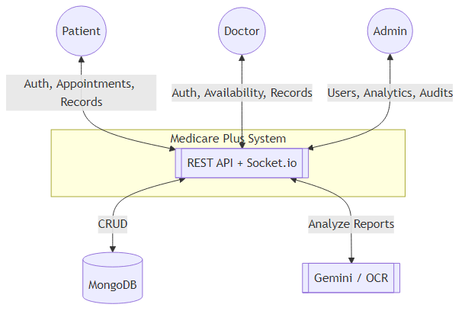

8.1 Appointment Booking (Sequence)
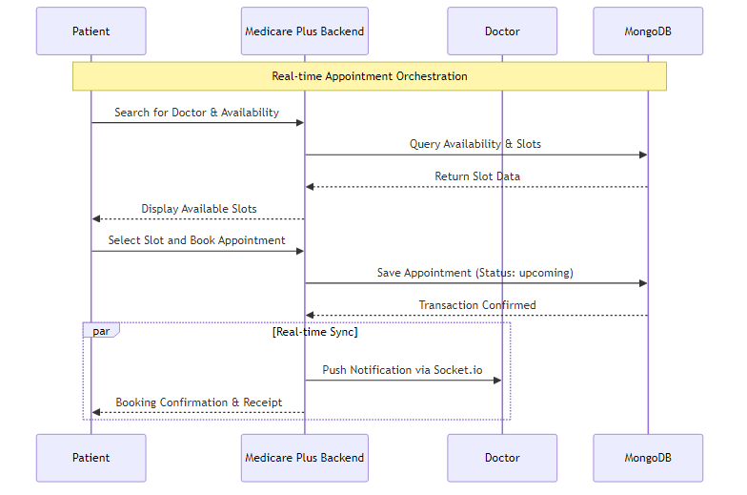

8.3 Data Flow Diagram (Level 1)

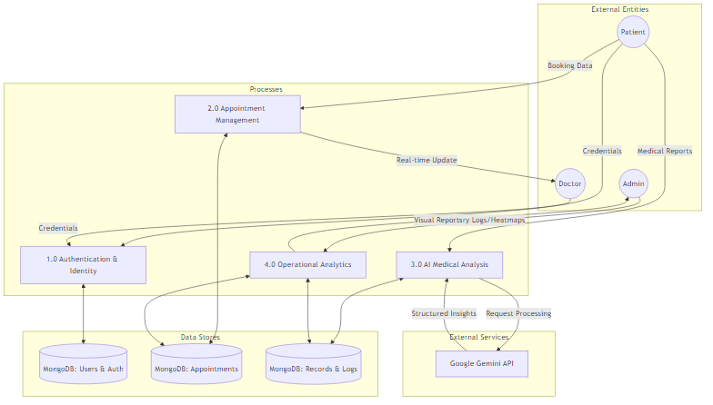

8.4 DFD Level 2: Appointment Management
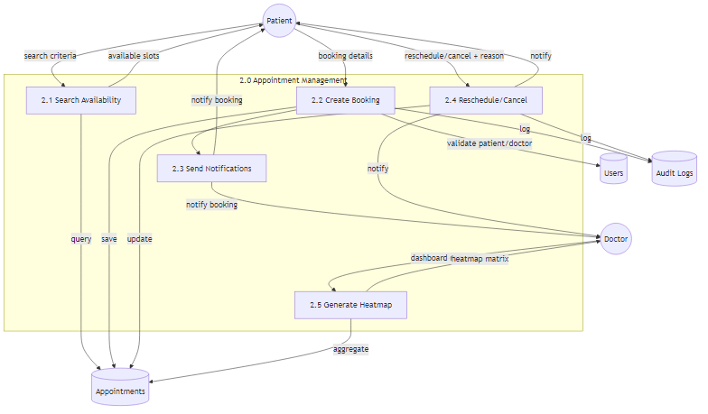

9. Detailed Specifications

9.1 API Endpoints (from backend/src/routes)
- Auth (`/api/auth`)
- POST `/register`, `/verify-otp`, `/resend-otp`, `/login`, `/logout`, `/forgot-password`, `/reset-password`, `/verify-mfa`
- POST `/refresh-token`
- GET `/doctors` (public), `/profile` (auth), `/sessions` (auth)
- PUT `/profile` (auth)
- Appointments (`/api/appointments`)
- POST `/book-appointment` (auth)
- GET `/my-appointments` (auth), `/heatmap` (auth)
- CRUD: `POST /`, `GET /`, `GET /:id`, `PUT /:id`, `DELETE /:id`
- Status: `PUT /:id/accept|reject|complete`, `PUT /:id/reschedule`
- AI Analysis (`/api/ai`)
- POST `/analyze` (auth, multipart `report`)
- Medical Records (`/api/medical-records`)
- GET `/my-records` (auth patient)
- GET `/doctor-records` (auth doctor)
- GET `/patient/:patientId` (auth doctor/admin)
- PATCH `/:id` (auth doctor/admin)
- PATCH `/:id/prescription` (auth doctor, multipart `prescription`)
- POST `/upload-report` (auth doctor, multipart `report`)
- PATCH `/:id/prescription-details` (auth doctor)
- Analytics (`/api/analytics`)
- GET `/stats`, `/doctor/:doctorName`, `/doctor/id/:doctorId`

AuthN/Z:
- JWT bearer tokens on protected endpoints; role checks where noted.
- Rate limiter on sensitive auth routes.
- File uploads via Multer with size limits (10 MB for AI route).

9.2 Data Dictionary (selected fields)
- User: `role ∈ {patient, doctor, admin}`, `isVerified:Boolean`, `failedLoginAttempts:Number`, `lockUntil:Date`, `knownLocations:[String]`
- Appointment: `mode ∈ {Online, Offline}`, `status ∈ {upcoming, completed, cancelled}`, `reminder24hSent:Boolean`, `reminder2hSent:Boolean`
- MedicalRecord: `status ∈ {pending, reviewed, archived}`, `analysis:Mixed`, `prescriptionUrl:String`
- AuditLog: `category ∈ {AUTH, APPOINTMENT, USER, ADMIN, SYSTEM}`, `ipAddress:String`, `userAgent:String`, `timestamp:Date`

9.3 Error Handling
- Consistent JSON error format: `code`, `message`, `details?`
- 400 validation errors; 401/403 auth/authorization; 404 not found; 409 conflicts; 500 server
- Include correlation ID in responses for tracing

---

10. Constraints, Risks, and Mitigations
- File storage on local disk in development; risk of disk saturation → use S3/MinIO in prod
- AI dependency downtime → queue requests and provide fallback/manual upload path
- PHI/PII handling → encrypt in transit; restrict access via RBAC and audit access
- Timezone drift → store timestamps in UTC; convert on client
- Rate-limiting tuning → balance user experience vs. abuse prevention

---

11. Verification and Validation
- Unit tests for controllers/services (happy-path and edge cases)
- API contract tests (request/response schemas)
- E2E tests (Cypress) for booking and records workflows
- Security tests: auth brute-force, token reuse, upload validation
- Load tests for key endpoints; chaos testing for resilience

---

12. Acceptance Criteria Summary
- Auth: verified users can login; locked accounts respect `lockUntil`; refresh rotation enforced
- Appointments: unique `appointmentId`; heatmap returns 7×24 matrix; reminders set flags
- Medical Records: AI `analysis` saved; status transitions enforce rules; prescriptions attach correctly
- Analytics: doctor and global stats return expected aggregates
- Audit: critical actions recorded with IP/UA; retention policy applied

---

13. Deployment and Operations
- Dockerized services; `docker-compose up --build` boots frontend/backend
- Environment variables: `PORT`, `EMAIL`, `EMAIL_PASS`, DB connection, AI keys
- Logging: structured server logs; consider centralization (ELK/CloudWatch)
- Backups: daily Mongo backups; restore runbooks documented
- Health checks: `GET /` and `/health` endpoints monitored

---

14. Traceability (excerpt)
- REQ-AUTH-1 → Auth middleware + route guards; tests: auth access matrix
- REQ-APPT-5 → GET `/api/appointments/heatmap`; tests: matrix shape/values
- REQ-MR-3 → POST `/api/ai/analyze`; tests: analysis schema presence
- REQ-AUD-1 → Audit logger middleware; tests: log entries on sensitive actions

